pasted-image.tiff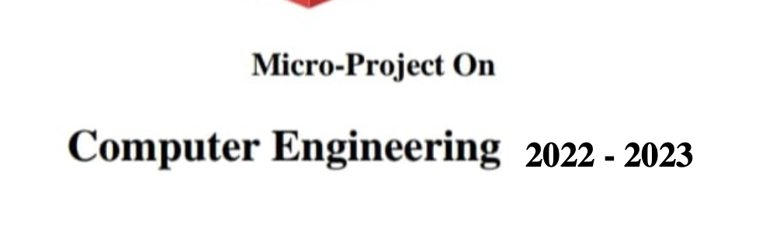

**2022 - 2023**

**LRU algorithm EXP 4,5,6 AND 13**



**MAHARASHTRA STATE**

**BOARD OF TECHNICAL EDUCATION**

**Certificate**

This is to certify that Mr. **SIDDIQUI MAMOON AHMAD FAZIL AHMAD** Roll No.**20461,** of Fifth Semester of Diploma in **COMPUTER ENGINEERING** of Institute **M. H. SABOO SIDDIK POLYTECHNIC (**Code: 0002) has completed the term work satisfactorily in course EDE (22032) for the academic year **2022-2023** as prescribed in the curriculum.

**Place:** MUMBAI **Enrollment No:** 2000020150

**Date:**  **Exam. Seat No:**

Subject Teacher Head of the Department Principal

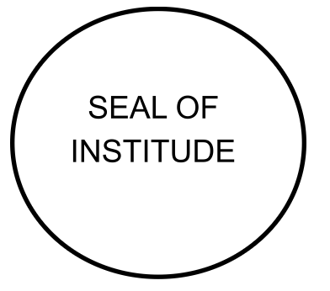







**MAHARASHTRA STATE**

**BOARD OF TECHNICAL EDUCATION**

**Certificate**

This is to certify that Mr. **SIDDIQUI SAAD AHMED SHAKEEL AHMED** Roll No.**20462,** of Fifth Semester of Diploma in **COMPUTER ENGINEERING** of Institute **M. H. SABOO SIDDIK POLYTECHNIC (**Code: 0002) has completed the term work satisfactorily in course EDE (22032) for the academic year **2022-2023** as prescribed in the curriculum.

**Place:** MUMBAI **Enrollment No:** 2000020148

**Date:** **Exam. Seat No:**

Subject Teacher Head of the Department Principal



** MAHARASHTRA STATE**

**BOARD OF TECHNICAL EDUCATION**

**Certificate**

This is to certify that Mr. **REHAN ASLAM WAGHOO** Roll No.**20463,** of Fifth Semester of Diploma in **COMPUTER ENGINEERING** of Institute **M. H. SABOO SIDDIK POLYTECHNIC (**Code: 0002) has completed the term work satisfactorily in course EDE (22032) for the academic year **2022-2023** as prescribed in the curriculum.

**Place:** MUMBAI **Enrollment No:** 2000020146

**Date: Exam. Seat No**:

Subject Teacher Head of the Department Principal





**MAHARASHTRA STATE**

**BOARD OF TECHNICAL EDUCATION**

**Certificate**

This is to certify that Mr. **KHOBRAGADE ASHISH VILAS** Roll No.**21482,** of Fifth Semester of Diploma in **COMPUTER ENGINEERING** of Institute **M. H. SABOO SIDDIK POLYTECHNIC (**Code: 0002) has completed the term work satisfactorily in course EDE (22032) for the academic year **2022-2023** as prescribed in the curriculum.

**Place:** MUMBAI **Enrollment No:** 2100020143

**Date: Exam. Seat No:**

Subject Teacher Head of the Department Principal



**ANNEXURE**

Evaluation sheet for the micro project

**Academic Year:** 2022-2023     **Name of faculty:** Mrs. Kousar Akumalla

**Course:** EDE      **Course code:** 22032   **Semester:** VI

**Title of the project:** Mobile Phone Manufacturing

**Cos addressed by Micro project:**

A. Identify your entrepreneurial traits.

B. Identify the business opportunities that suits you.

C. Develop comprehensive business plans.

D. Prepare plans to manage the enterprise effectively.

**Major learning outcomes achieved by students by doing the Project:**

(a)Practical outcomes.

(b)Unit outcomes in Cognitive domain

(c)Outcomes in effective domain

Comments/suggestions about teamwork/leadership/inter-personal communication (if any): -

|  |  |  |  |  |
| --- | --- | --- | --- | --- |
| Roll no. | Student Name | Marks out of 6 for performance in group activity | Marks out of 4 for performance in oral/presentation | Total out of 10 |
| 20461 | SIDDIQUI MAMOON AHMAD FAZIL AHMAD |  |  |  |
| 20462 | SIDDIQUI SAAD AHMED SHAKEEL AHMED |  |  |  |
| 20463 | WAGHOO REHAN ASLAM |  |  |  |
| 21482 | KHOBRAGADE ASHISH VILAS |  |  |  |

**Stories Of Successful Entrepreneur**

**1. Founder of Walmart: Sam Walton**

Samuel Moore Walton (March 29, 1918 – April 5, 1992) was an American business magnate best known for founding the retailers Walmart, which he started in 1962 and 1983 respectively. Wal-Mart Stores Inc. grew to be the world's largest corporation by revenue as well as the biggest private employer in the world. For a period of time, Walton was the richest man in America.



**Early Life:** Samuel Moore Walton was born to Thomas Gibson Walton and Nancy Lee, in Kingfisher, Oklahoma. He lived there with his parents on their farm until 1923. However, farming did not provide enough money to raise a family, and Thomas Walton went into farm mortgaging. He worked for his brother's Walton Mortgage Company, which was an agent for Metropolitan Life Insurance, where he foreclosed on farms during the Great Depression.

He and his family (now with another son, James, born in 1921) moved from Oklahoma. They moved from one small town to another for several years, mostly in Missouri. While attending eighth grade in Shelbina, Missouri, Sam became the youngest Eagle Scout in the state's history. In adult life, Walton became a recipient of the Distinguished Eagle Scout Award from the Boy Scouts of America.

After high school, Walton decided to attend college, hoping to find a better way to help support his family. He attended the University of Missouri as an ROTC cadet. During this time, he worked various odd jobs, including waiting tables in exchange for meals.

Walton joined J. C. Penney as a management trainee in Des Moines, Iowa, three days after graduating from college. Soon afterwards, Walton joined the military in the U.S. Army Intelligence Corps, supervising security at aircraft plants.

**The First Stores**: In 1945, after leaving the military, Walton took over management of his first variety store at the age of 26. With the help of a $20,000 loan from his father-in-law, plus $5,000 he had saved from his time in the Army, Walton purchased a Ben Franklin variety store in Newport, Arkansas. The store was a franchise of the Butler Brothers chain.

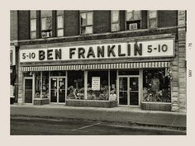

Walton pioneered many concepts that became crucial to his success. According to Walton, if he offered prices as good or better than stores in cities that were four hours away by car, people would shop at home. Walton made sure the shelves were consistently stocked with a wide range of goods. His second store, the tiny "Eagle" department store, was down the street from his first Ben Franklin and next door to its main competitor in Newport.

**First Walmart:** The first true Walmart opened on July 2, 1962, in Rogers, Arkansas. Called the Wal-Mart Discount City store, it was located at 719 West Walnut Street. He launched a determined effort to market American-made products. Included in the effort was a willingness to find American manufacturers who could supply merchandise for the entire Walmart chain at a price low enough to meet the foreign competition.

As the Meijer store chain grew, it caught the attention of Walton. He came to acknowledge that his one-stop-shopping center format was based on Meijer's original innovative concept. Contrary to the prevailing practice of American discount store chains, Walton located stores in smaller towns, not larger cities. To be near consumers, the only option at the time was to open outlets in small towns. Walton's model offered two advantages. First, existing competition was limited and secondly, if a store was large enough to control business in a town and its surrounding areas, other merchants would be discouraged from entering the market.

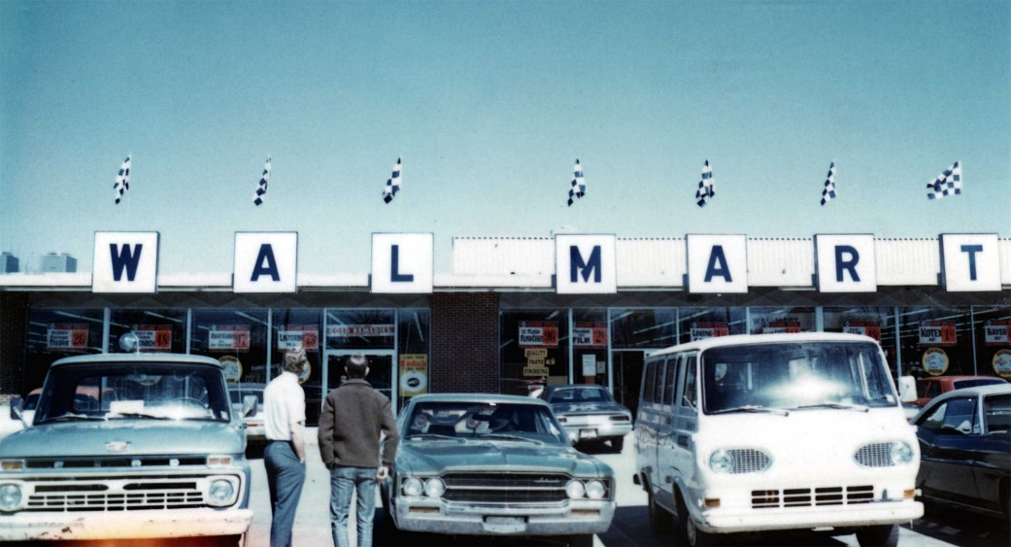

**2. Founder of OnePlus: Pete Lau**

Pete Lau, or Liu Zuohu (Chinese: 刘作虎; pinyin: Liú Zuòhǔ; Jyutping: Lau4 Zok3fu2), is a Chinese entrepreneur and business executive. He is the co-founder and the chief executive officer of Chinese smartphone maker OnePlus.



**Career In Oppo:** Lau started working in Oppo as a hardware engineer. He later became the director of Oppo's Blu-ray division. Lau's attention for detail became famous in tech circles during that time when he smashed a Blu-ray player's logic board to express his disappointment about the circuitry design. He then became head of marketing before finally getting assigned as the Vice President. As the Vice President, he was instrumental in bringing CyanogenMod, an Android-based operating system, to Oppo N1 smartphone. He resigned from Oppo in November 2013 after working in the company for over a decade.

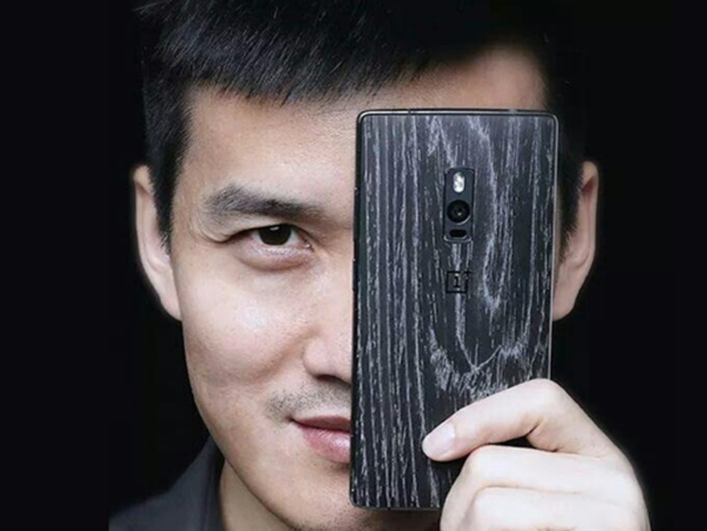**OnePlus:** In December 2013, Lau and Carl Pei launched their own company named "OnePlus" with the aim of creating "a more beautiful and higher quality product." At the time of its founding, OnePlus had only 6 employees. Cutting costs was a priority for the company early on, so Lau opted to sell his company's first product exclusively online, taking inspiration from market models of the Nexus line and Oppo. He chose Cyanogenmod as the device's operating system and extended his ties with Stefanie Kondik of Cyanogen Inc., whom he became acquainted with during his time at Oppo.

Since OnePlus didn't have a manufacturing facility, Lau had the device manufactured in the facilities of his former company Oppo. The device named OnePlus One was announced officially in April 2014 and became available for online order in June 2014. OnePlus One received positive reviews from the tech community, praising the phone's specifications, performance, design and aggressive pricing. The device's attention to detail, an aspect that can be attributed to Lau, was praised by several tech experts. Due to limited product supply, the phone was initially available for purchase through an invite-only system.

The phone's pricing was discussed widely in tech media. The 16 GB version of the phone cost USD 299 while the 64 GB version cost USD 349, almost half the price of other flagship devices at that time with similar specifications. Lau attributed the low prices to the lack of marketing costs, the online marketing strategy, and low profit margins. The strategy was labelled as brave and risky for a new company by tech website Tech Radar. Another tech site, Phone Arena, commented that "if OnePlus can succeed selling its smartphone without television advertising, it will have done something that the major manufacturers could never accomplish."

By December 2014, nearly 1 million phones were sold. OnePlus announced another OS "OxygenOS" for their smartphones when YU Televentures, a subsidiary of Micromax, announced that they alone had permission for the use of Cyanogen OS in India.

**3. Founder of WhatsApp: Brian Acton**

Brian Acton (born 1972/1973) is an American computer programmer and Internet entrepreneur. Acton is the executive chairman of the Signal Technology Foundation, which he co-founded with Moxie Marlinspike in 2018. As of January 10, 2022, Acton also serves as interim CEO of Signal Messenger LLC.

He was formerly employed at Yahoo!, and co-founded WhatsApp, a mobile messaging application which was acquired by Facebook in February 2014 for US$19 billion, with Jan Koum. Acton left WhatsApp in September 2017 to start the Signal Foundation. According to Forbes (2020), Acton is the 836th-richest person in the world, with a net worth of $2.5 billion.



**Early life and education:** Acton grew up in Michigan, later moving to Central Florida where he graduated from Lake Howell High School. Acton received a full scholarship to study engineering at the University of Pennsylvania but left after a year to study at Stanford. He graduated from Stanford University in 1994 with a degree in computer science.

**Career:** In 1992, he became a systems administrator for Rockwell International, before becoming a product tester at Apple Inc. and Adobe Systems. In 1996, he joined Yahoo Inc.

**Yahoo!**

In 1998, Jan Koum was hired by Yahoo! as an infrastructure engineer shortly after he met Acton while working at Ernst & Young as a security tester. Over the next nine years, they worked at Yahoo!.

**WhatsApp**

In 2014, Koum and Acton sold WhatsApp to Facebook for approximately US$19 billion in cash and stock. Forbes estimated that Acton held over 20% stake in the company, making his net worth around $3.8 billion.

In 2016, Acton led a funding round for Trak N Tell and raised $3.5 million along with two other investors.

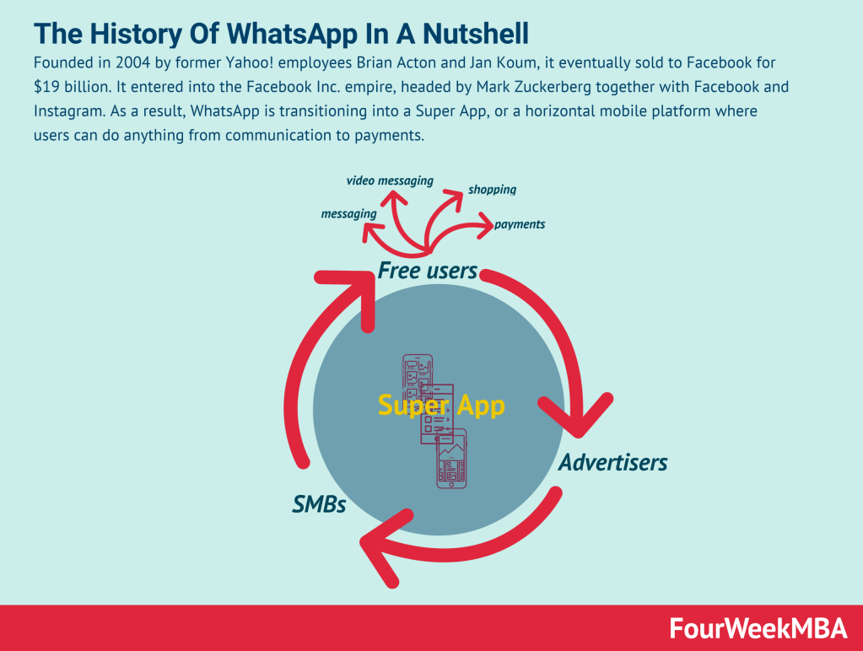

In September 2017, Acton left WhatsApp. Acton told Forbes that he left over a dispute with Facebook regarding monetization of WhatsApp, and voluntarily left $850 million in unvested options on the table by leaving a few months before vesting was completed. He also said that he was coached by Facebook executives to mislead European regulators regarding Facebook's intention to merge Facebook and WhatsApp user data.

**Signal**

Acton left WhatsApp in September 2017 to start a new foundation, the Signal Foundation, which is dedicated to helping people have access to private communication through an encrypted messaging app. Signal is broadly used by journalists and human rights activists.

**A Story of Unsuccessful Entrepreneur**

**PepperTap**

Started in 2014 in Gurgaon, India, PepperTap was the brainchild of Milind Sharma and Navneet Singh. Both the founders were IIM alumni and were often called “two intellectual superpowers”, who were put together to make the ultimate Indian startup dream a reality.

Both Sharma and Singh just had one objective – to make grocery shopping in India simple. And the way to do that was to scrap the old method and revolutionize it via the internet.



It would be no more haggling, no more adulterated products, and no more lack of choice. PepperTap would act as an aggregator for grocery stores around the user, compiling the best rates and then delivering what the users want, right to their doorstep. It was somewhat of an e-commerce and aggregation venture, but only for groceries.

**COLLAPSE**

In April 2016, PepperTap announced that it was pulling its shutters down for good. From a few months, they had started scaling back on cities and had undergone a few massive rounds of layoffs as well.

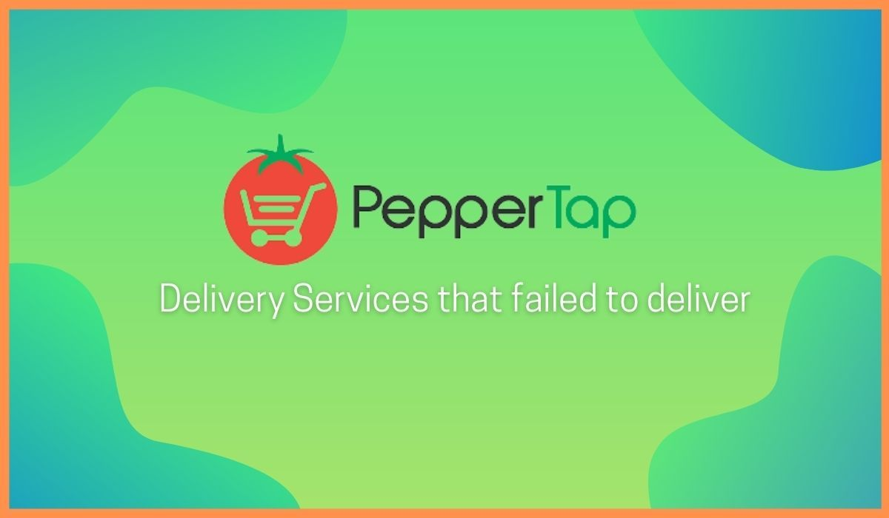 **1. Unsustainable Cash Burn**

PepperTap’s heavy funding meant that the company could afford to give off offers like discounts and free delivery service. Needless to say, this was what attracted most consumers. They also went all out on their marketing initiatives and heavily promoted the app and the website.

**2. No Inventory**

PepperTap was one of the few startups that did not own any inventory at all. They didn’t sell products that were under their control. They only collated inventories which were there with other grocery stores and then updated their offerings.

**3. 2016 Funding Drought**

2016 was a bad year for startups all across India. There was a complete and utter lack of funding and the growth of a lot of companies stagnated, reduced, or was massively hit. Successful companies like TinyOwl were shut down and even bigger ones like Zomato recorded slower financial growth than ever.

Needless to say, this drought hit PepperTap. The company was not making any money from sales and also had a high cash-burn business model. This coupled with a lack of funding put tremendous pressure. This pressure ultimately forced PepperTap to shut down in April 2016.

**Case Study on Apple Inc.**

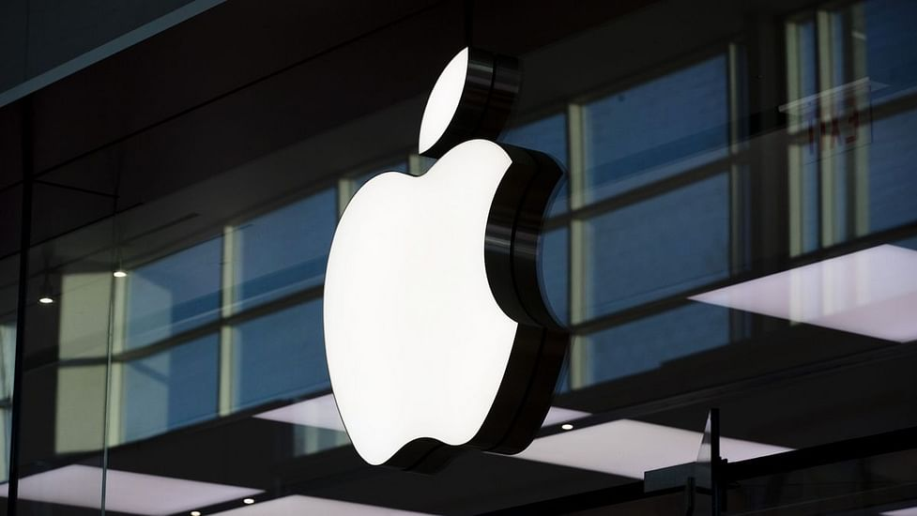**1. Background and History:**

Apple Inc. was founded on April 1, 1976, by Steve Jobs, Steve Wozniak, and Ronald Wayne in Cupertino, California, USA. Originally known as Apple Computer Inc., the company started in Jobs' garage and initially focused on manufacturing and selling personal computers. The Apple I, the company's first product, was a single-board computer sold as a kit. In 1977, Apple introduced the Apple II, a fully assembled personal computer that became a commercial success and helped establish Apple as a leader in the emerging personal computer market.

**2. Success Story:**

Apple's success story is marked by its innovative products and design-driven approach. In 1984, Apple introduced the Macintosh, which was the first commercially successful personal computer to feature a graphical user interface and a mouse. However, Apple faced challenges in the 1990s due to increased competition and declining sales. In 1997, Steve Jobs returned to Apple as CEO and initiated a major turnaround. Under his leadership, Apple introduced a series of groundbreaking products, including the iMac, iPod, iPhone, and iPad, which transformed entire industries and made Apple one of the most valuable technology companies in the world.



**3. Marketing Strategy:**

Apple's marketing strategy is centered around product innovation, brand building, and creating an emotional connection with customers. The company's marketing campaigns focus on highlighting the unique features and design of its products, creating a sense of aspiration and emotional attachment among consumers. Apple also leverages its loyal customer base and brand advocates to create buzz and generate word-of-mouth marketing. The company's minimalist and sleek product packaging, distinctive logo, and iconic retail stores also contribute to its branding and marketing efforts.

**4. Revenue Model:**

Apple's revenue model is based on selling hardware products, services, and other products. The majority of its revenue comes from the sales of iPhones, iPads, Macs, and other hardware products. In addition, Apple generates revenue from its services, including the App Store, Apple Music, iCloud, AppleCare, and other subscription-based services. Apple also generates revenue from other products, such as iTunes, Apple Pay, accessories, and licensing fees. The company's integrated ecosystem of products and services creates a strong lock-in effect, driving customer retention and generating recurring revenue.

**5. Funding:**

Apple Inc. has largely relied on its internal funds and generated revenue to finance its operations and product development. However, the company has also raised funds through debt offerings and issued bonds to finance its capital expenditures and share buybacks. In 1980, Apple conducted its initial public offering (IPO), which raised $97 million and helped fund its expansion plans. Since then, Apple has become one of the most valuable publicly traded companies, with a market capitalization of over $2 trillion as of 2023.

**6. Innovation and Design:**

Apple's success has been largely driven by its focus on product innovation and design. The company has a strong culture of innovation, constantly pushing the boundaries of technology and design to create unique and user-friendly products. Apple's design-driven approach is reflected in its minimalist product design, intuitive user interfaces, and attention to detail. The company has also been known for its seamless integration of hardware, software, and services, creating a cohesive and user-friendly ecosystem.

**7. Supply Chain Management:**

Apple has a complex global supply chain that involves various partners, including component suppliers, contract manufacturers, and logistics providers. The company has established strict quality control standards and works closely with its suppliers to ensure that its products meet the highest quality standards. Apple's supply chain management practices have been recognized for their efficiency and effectiveness, enabling the company to maintain a consistent supply of products to meet customer demand and minimize inventory levels.

**8. Competitive Advantage:**

Apple's competitive advantage lies in its focus on innovation, design, and brand loyalty. The company has a reputation for creating products that are user-friendly, intuitive, and aesthetically appealing. Its integrated ecosystem of products and services, including hardware, software, and services, creates a seamless user experience and promotes customer loyalty. Apple also invests heavily in research and development (R&D) to stay at the forefront of technology and maintain a competitive edge in the fast-paced tech industry.

**9. Customer Relationship Management:**

Apple has a strong customer relationship management (CRM) strategy that focuses on building a loyal customer base and creating a personalized experience for its customers. The company maintains a robust ecosystem of products and services that are designed to work seamlessly together, creating a lock-in effect that promotes customer retention. Apple also has a comprehensive customer support system, including online and offline customer service, Apple Care, and Apple Support communities, to provide timely assistance and resolve customer issues.

**10. Corporate Social Responsibility:**

Apple has made efforts to address social and environmental concerns through its corporate social responsibility (CSR) initiatives. The company has set ambitious environmental goals, including using 100% renewable energy for its operations and products, reducing its carbon footprint, and conserving resources. Apple also has programs to promote diversity and inclusion, ethical sourcing of materials, and responsible recycling of its products. These CSR efforts are aimed at enhancing Apple's reputation, promoting sustainability, and meeting the expectations of socially-conscious consumers.

**11. Challenges:**

Despite its remarkable success, Apple has faced several challenges over the years. These challenges include increasing competition from rivals, legal battles over intellectual property, supply chain disruptions, and criticism over labor practices in its supply chain. Apple has also faced public scrutiny over issues such as data privacy and security, environmental impact, and labor conditions. However, the company has responded to these challenges by implementing measures to improve its supply chain practices, addressing labor concerns, and enhancing its environmental initiatives.

In conclusion, Apple Inc. has a rich history of innovation, design, and success. Its marketing strategy, revenue model, funding, innovation, supply chain management, competitive advantage, customer relationship management, corporate social responsibility, and challenges have shaped the company into one of the most valuable technology companies in the world. Apple's ability to create innovative products, build a strong brand, and maintain a loyal customer base has been key to its success in the fiercely competitive tech industry.

**Business Idea**

A business idea is a concept that can be used for financial gain that is usually centered on a

product or service that can be offered for money. An idea is the first milestone in the process

of building a successful business.

The characteristics of a promising business idea are:

* Innovative
* Unique
* Problem solving
* Profitable
* Understandable

A business idea is often linked to its creator who needs to identify the business' value

proposition in order to launch to market and establish competitive advantage. A business idea

is the first spark of Entrepreneurship.

**Our business idea is Mobile Phone Manufacturing Industry which is similar to Apple Inc.**

* Idea: Establish a mobile manufacturing company that prioritizes sustainability and ethical practices.
* Target market: Environmentally conscious and socially responsible consumers.
* Business model: Manufacture and sell smartphones that are environmentally friendly and ethically produced.
* Marketing strategy: Promote sustainability, ethical practices, and social responsibility through branding and partnerships.
* Competitive advantage: Unique value proposition of offering smartphones with a strong focus on sustainability.
* Challenges: Sourcing sustainable materials, managing supply chains, educating consumers, and potential price sensitivity.
* Conclusion: Opportunity to tap into growing demand for environmentally friendly and socially responsible products in the mobile manufacturing industry.

**Business Plan**

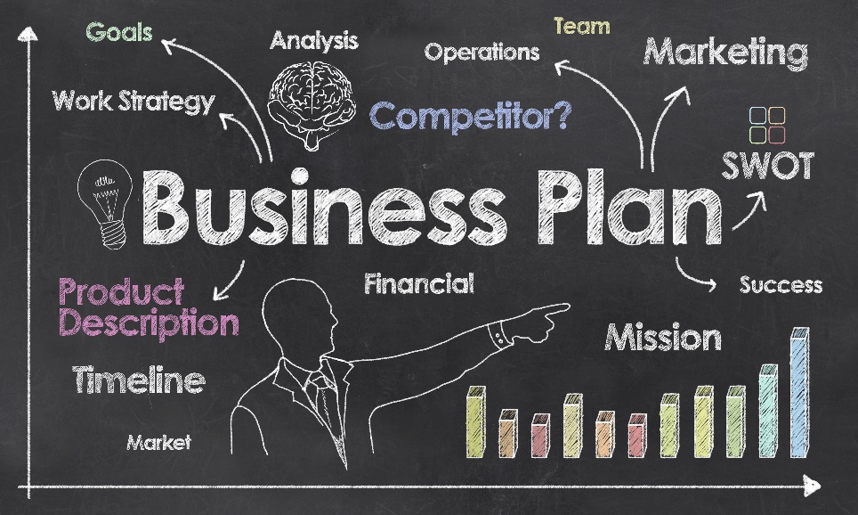 A business plan is a written document that outlines a company's goals, objectives, strategies, and financial projections for the purpose of starting, managing, and growing a business. It serves as a roadmap that provides direction and guidance to the company's operations and decision-making. A well-structured and comprehensive business plan typically includes the following key components:

* Executive Summary: Provides an overview of the business, including its mission, vision, and key highlights.
* Company Description: Provides information on the company's history, legal structure, ownership, and location.
* Market Analysis: Conducts a thorough analysis of the market, including market size, trends, customer segments, competition, and opportunities.
* Product/Service Line: Describes the products or services that the company offers, highlighting their unique features, benefits, and pricing.
* Marketing and Sales Strategy: Outlines the company's marketing and sales plans, including target market, branding, advertising, and distribution channels.
* Operations Plan: Details the company's operational processes, including production, supply chain management, quality control, and customer service.
* Financial Plan: Presents the company's financial projections, including sales forecasts, expenses, profitability, funding requirements, and exit strategy.

**Business Plan For Mobile Manufacturing Industry**

**I. Executive Summary**

* Brief overview of the company and its products: For example, the mobile manufacturing company could be called "TechMobile," and it produces high-quality smartphones and accessories. TechMobile differentiates itself from its competitors by offering innovative features, such as advanced camera technology and long battery life.
* Description of target market and competitors: TechMobile's target market is young professionals and tech enthusiasts who value high-quality technology and are willing to pay a premium for it. Its key competitors include Apple, Samsung, and Huawei.
* Financial projections and funding requirements: TechMobile expect to generate $10 million in revenue in its first year of operation and anticipates needing $5 million in funding to get started.

**II. Company Overview**

* Mission statement and vision for the company: TechMobile's mission is to provide customers with innovative and high-quality technology products that enhance their lives. Its vision is to become a leading player in the mobile phone industry.
* History and background of the company: TechMobile was founded in 2021 by a team of experienced entrepreneurs who have a deep understanding of the mobile phone industry.
* Legal structure of the company: TechMobile is set up as a limited liability company (LLC) to protect the owners' personal assets.

**III. Products and Services**

* Description of mobile phones and accessories offered: TechMobile offers a range of smartphones and accessories, including cases, screen protectors, and chargers. For example, its flagship product is the TechMobile X, a smartphone with a 6.5-inch OLED display, 128 GB of storage, and a 64-megapixel camera.
* Unique selling points and competitive advantage: TechMobile's unique selling points include its innovative features, such as advanced camera technology and long battery life. Its competitive advantage is its affordable pricing, which makes its products accessible to a wider range of customers.
* Research and development plans for future products: TechMobile plans to invest heavily in research and development to continue to innovate and bring new products to market. For example, it is currently developing a foldable smartphone that will launch in 2023.

**IV. Market Analysis**

* Industry analysis and trends: The mobile phone industry is a rapidly growing market, with an expected global market size of $1.36 trillion by 2026. Key trends include the shift towards 5G technology and the increasing importance of smartphone cameras.
* Market segmentation and target market: TechMobile's target market is young professionals and tech enthusiasts who value high-quality technology and are willing to pay a premium for it. In the US, this demographic represents approximately 25% of the total smartphone market.
* Competitor analysis and differentiation strategy: TechMobile differentiates itself from its competitors by offering innovative features and affordable pricing. For example, the TechMobile X is priced at $699, compared to the iPhone 13 Pro Max, which is priced at $1,099.

**V. Marketing and Sales Strategy**

* Promotional activities, advertising, and public relations: TechMobile plans to use a variety of promotional activities to reach customers, including social media advertising, influencer partnerships, and targeted email campaigns.
* Sales channels and distribution strategy: TechMobile will initially sell its products online through its website and Amazon. It plans to expand into retail distribution in the future.
* Pricing strategy and positioning in the market: TechMobile's pricing strategy is to offer premium products at an affordable price point, positioning itself as a high-quality but accessible brand.

**VI. Operations Plan**

* Production process and facilities: TechMobile plans to manufacture its products in China, where it will work with a trusted partner to ensure high-quality production.
* Inventory management: TechMobile will use a just-in-time inventory management system to minimize inventory costs and ensure timely delivery of products to customers.
* Quality control and assurance: TechMobile will implement strict quality control measures to ensure that its products meet high standards of quality and reliability.
* Customer service and support: TechMobile will provide excellent customer service and support to build customer loyalty and enhance its brand reputation.

**VII. Financial Plan**

* Financial projections and assumptions: TechMobile expect to generate $10 million in revenue in its first year of operation, with a gross margin of 50%. It anticipates needing $5 million in funding to get started, which will be raised through a combination of equity and debt financing.
* Break-even analysis and profitability: TechMobile's break-even point is estimated to be at around $2.5 million in revenue. It expects to achieve profitability in its second year of operation, with a net income of $3 million.
* Cash flow projections and funding requirements: TechMobile's cash flow projections indicate that it will need $5 million in funding to cover startup costs and operating expenses in its first year. It plans to use a combination of equity and debt financing to raise this capital.
* Exit strategy: TechMobile's long-term goal is to become a leading player in the mobile phone industry and eventually go public or be acquired by a larger company.

**VIII. Conclusion**

* Summary of key points: TechMobile is a mobile manufacturing company that offers innovative and high-quality smartphones and accessories at an affordable price point. Its target market is young professionals and tech enthusiasts who value high-quality technology.
* Future outlook: TechMobile plans to continue to innovate and bring new products to market, with a focus on research and development. It aims to become a leading player in the mobile phone industry and eventually go public or be acquired by a larger company.

**Technical Feasibility Report for Mobile Manufacturing Industry**

A technical feasibility report is a document that assesses the technical viability of a proposed project or business venture. It focuses on evaluating the technological aspects of the project, such as the availability and suitability of required resources, equipment, infrastructure, and expertise to carry out the project successfully. The technical feasibility report typically includes an analysis of the production process, required technology, potential challenges, and recommendations for implementing the project effectively.

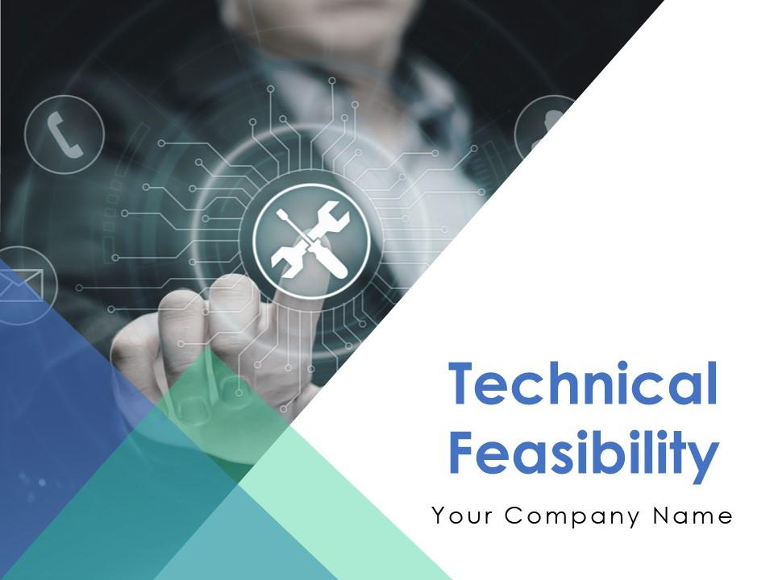

TechMobile

The purpose of a technical feasibility report is to determine whether the proposed project or venture is technically achievable and can be implemented using available technology and resources. It helps stakeholders, including investors, management, and decision-makers, make informed decisions about the viability of the project. The report may also highlight any potential technical risks or challenges that may arise during the implementation of the project and provide recommendations to mitigate those risks.

**I. Introduction**

The purpose of this technical feasibility report is to assess the feasibility of setting up a mobile manufacturing industry, based on real-life figures and examples. The report will focus on the technical aspects of mobile manufacturing, including the production process, required infrastructure, technological capabilities, and potential challenges, using real-life data and examples for illustration.

**II. Production Process**

The production process for mobile manufacturing typically involves several stages, including design, procurement of components, assembly, testing, and packaging. For example, a typical production process for a smartphone may involve the following steps:

* Design: Designing the mobile device, including its form factor, specifications, and features using computer-aided design (CAD) software.
* Procurement of Components: Procuring various components, such as the processor, display, camera, battery, and other parts from reliable suppliers.
* Assembly: Assembling the components together to form the final mobile device, which may involve manual labor and automated assembly lines.
* Testing: Conducting comprehensive testing, including functionality, performance, and quality testing, to ensure that the mobile device meets the required standards.
* Packaging: Packaging the mobile devices in appropriate packaging materials, including boxes, plastics, and other materials, for shipment.

**III. Required Infrastructure**

Setting up a mobile manufacturing industry requires adequate infrastructure to support the production process. For example, the infrastructure may include:

* Production Plant: A production plant with sufficient space and layout for efficient production processes, including assembly lines, testing stations, and packaging units.
* Warehouses: Warehouses for storage of components and finished products, with proper storage and inventory management systems in place.
* Testing Labs: Testing labs equipped with modern testing equipment and facilities to conduct thorough quality control checks on the mobile devices.
* Packaging Units: Packaging units with appropriate machinery and materials for efficient and standardized packaging of the mobile devices.
* Utilities: Access to reliable utilities such as electricity, water, and internet, to support the production processes.

**IV. Technological Capabilities**

Mobile manufacturing is a technology-driven industry, and staying up-to-date with the latest technological advancements is crucial for success. Technological capabilities may include:

* Design Software: Computer-aided design (CAD) software for designing mobile devices with advanced features and specifications.
* Automated Assembly Lines: Automated assembly lines with robotic arms, conveyor belts, and other advanced equipment for efficient and fast assembly of mobile devices.
* Testing Equipment: Modern testing equipment for conducting comprehensive testing, including functionality, performance, and quality testing.
* Software Integration: Integration of software and firmware into mobile devices, including operating systems, applications, and other software components.
* Customization Capabilities: Technological capabilities to customize mobile devices based on customer requirements, such as color options, storage capacities, and other specifications.

**V. Potential Challenges**

The mobile manufacturing industry faces several potential challenges that need to be considered in the technical feasibility report. Some of these challenges may include:

* Intense Competition: The mobile manufacturing industry is highly competitive, with numerous global and local players, which may impact market share and pricing.
* Rapid Technological Advancements: The mobile industry is characterized by rapid technological advancements, which may require continuous investment in research and development to stay updated and competitive.
* Changing Customer Preferences: Customer preferences and demands may change rapidly, requiring flexibility in the manufacturing process to adapt to changing market trends.
* Supply Chain Management: Managing a complex global supply chain for sourcing components, materials, and equipment may pose challenges in terms of reliability, quality, and lead times.
* Regulatory Compliance: Compliance with regulatory requirements, including safety, environmental, and labor regulations, may add complexity and cost to the manufacturing process.

**VI. Conclusion**

Based on the assessment of the technical aspects of mobile manufacturing, using real-life figures and examples, it can be concluded that setting up a mobile manufacturing industry can be technically feasible, but also challenging. The production process involves various stages, including design, procurement of components, assembly, testing, and packaging, which require adequate infrastructure, including production plants, warehouses, testing labs, packaging units, and reliable utilities. Technological capabilities, such as design software, automated assembly lines, testing equipment, software integration, and customization capabilities, are also essential for success in the mobile manufacturing industry.

However, there are potential challenges that need to be addressed, such as intense competition, rapid technological advancements, changing customer preferences, supply chain management, and regulatory compliance. These challenges may require strategic planning, continuous innovation, and effective management to mitigate risks and ensure smooth operations.

Real-life figures and examples can further illustrate the technical feasibility of a mobile manufacturing industry. For example:

* According to market research, the global smartphone market was valued at USD 522.91 billion in 2020 and is expected to reach USD 944.43 billion by 2027, indicating a growing demand for smartphones.
* Established mobile manufacturing companies, such as Apple, Samsung, and Huawei, have invested heavily in advanced technologies, automated assembly lines, and robust supply chain management to streamline their production processes and gain a competitive edge.
* Customization capabilities have become a key trend in the mobile industry, with companies offering options for consumers to choose different colors, storage capacities, and other specifications, leading to increased customer satisfaction and brand loyalty.
* Compliance with regulatory requirements, such as safety standards, environmental regulations, and labor laws, is crucial for mobile manufacturers to ensure product quality, safety, and ethical practices in their operations.

In conclusion, while setting up a mobile manufacturing industry can be technically feasible, it requires careful consideration of production processes, required infrastructure, technological capabilities, and potential challenges. Real-life figures and examples can provide valuable insights into the industry's dynamics and help stakeholders make informed decisions about the feasibility and viability of the project.

**Financial Feasibility Report for Mobile Manufacturing Industry**

A Financial Feasibility Report is a comprehensive analysis of the financial aspects of a business or project to determine its viability and sustainability. It involves evaluating the financial feasibility of a proposed venture or investment by examining various financial factors such as projected costs, revenues, profits, cash flow, return on investment (ROI), payback period, and other financial metrics. The purpose of a Financial Feasibility Report is to assess whether the project or business is financially viable and can generate sufficient returns to justify the investment of resources and capital.

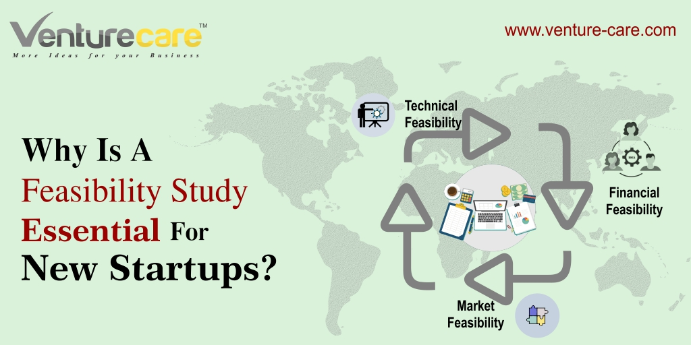

A Financial Feasibility Report serves as a crucial tool for decision-makers, investors, lenders, and other stakeholders to assess the financial viability and sustainability of a business or project. It helps in making informed decisions, identifying potential risks and challenges, and developing strategies to ensure financial success.

**1. Financial Projections:** Provide detailed financial projections, including sales forecasts, expenses, profitability, and cash flow projections. For example:

* Sales Forecast: Projected sales volume and revenue based on market research and industry trends. E.g., projected sales of 100,000 mobile phones in the first year, generating $10 million in revenue.
* Projected unit sales: 100,000 mobile phones in the first year, 150,000 in the second year, and 200,000 in the third year.
* Average selling price: $100 per mobile phone in the first year, $95 in the second year, and $90 in the third year.
* Total projected sales revenue: $10 million in the first year, $14.25 million in the second year, and $18 million in the third year.
* Expenses: Breakdown of fixed and variable expenses, such as manufacturing costs, labor costs, overheads, marketing expenses, and administrative expenses. E.g., projected manufacturing costs of $6 million in the first year.
* Manufacturing costs: $60 per mobile phone in the first year, including materials, labor, and overheads.
* Marketing expenses: $500,000 in the first year for advertising, promotions, and other marketing activities.
* Administrative expenses: $200,000 per year for salaries, office rent, utilities, and other administrative costs.
* Profitability: Calculation of gross profit, operating profit, and net profit margins based on projected sales and expenses. E.g., projected gross profit margin of 40%, operating profit margin of 20%, and net profit margin of 15% in the first year.
* Gross profit margin: 40% in the first year, 45% in the second year, and 50% in the third year.
* Operating profit margin: 20% in the first year, 25% in the second year, and 30% in the third year.
* Net profit margin: 15% in the first year, 18% in the second year, and 20% in the third year.
* Cash Flow: Projection of cash inflows and outflows, including working capital requirements, capital expenditures, loan repayments, and tax payments. E.g., projected positive cash flow of $2 million in the first year.

**2. Funding Requirements:** Specify the funding requirements of the mobile phone manufacturing business, including start-up costs, working capital needs, and capital expenditures. For example:

* Start-up Costs: Estimate of initial costs to set up the manufacturing facility, purchase equipment, hire employees, and launch the business. E.g., start-up costs of $3 million.
* Working Capital: Estimate of ongoing working capital needs to cover inventory, raw materials, labor, and other operational expenses. E.g., working capital requirements of $1 million per year.
* Capital Expenditures: Projection of future capital expenditures for equipment upgrades, expansion, or technology investments. E.g., capital expenditures of $2 million over the next five years.

**3. Financial Risks:** Identify and analyze potential financial risks associated with the mobile phone manufacturing business, such as market risks, operational risks, regulatory risks, and financial risks. Provide strategies to mitigate these risks. For example:

* Market Risks: Risks associated with changes in market demand, competition, and technological advancements. E.g., mitigating market risks by conducting regular market research, diversifying customer segments, and staying updated with industry trends.
* Operational Risks: Risks associated with production delays, supply chain disruptions, quality control issues, and labor costs. E.g., mitigating operational risks by implementing robust production processes, maintaining good relationships with suppliers, and investing in quality control measures.
* Regulatory Risks: Risks associated with changes in regulations, tariffs, and trade policies. E.g., mitigating regulatory risks by staying compliant with local and international regulations, monitoring changes in trade policies, and seeking legal counsel.
* Financial Risks: Risks associated with cash flow, debt management, and financial stability. E.g., mitigating financial risks by maintaining healthy cash flow, managing debt levels, and building financial reserves.

**4. Break-even Analysis:** Provide a break-even analysis to determine the minimum sales volume needed to cover all fixed and variable costs and start generating profits. This can help assess the company's financial sustainability and viability. For example:

* Break-even point: 50,000 units in the first year, 75,000 units in the second year, and 100,000 units in the third year.
* Break-even sales revenue: $5 million in the first year, $7.125 million in the second year, and $9 million in the third year.

**5. Cash Flow Projections:** Include detailed cash flow projections to analyze the company's cash inflows and outflows over a period of time. This can help assess the company's liquidity and ability to meet financial obligations. For example:

* Monthly cash inflows: Sales revenue, loans, investments, and other sources.
* Monthly cash outflows: Operating expenses, loan repayments, taxes, and other financial obligations.
* Ending cash balance: Ensuring positive cash balances at the end of each month/year to meet financial needs and avoid cash flow shortages.

**6. Return on Investment (ROI):** Calculate the projected ROI for investors or stakeholders to assess the company's profitability and potential returns. For example:

* ROI: 15% in the first year, 18% in the second year, and 20% in the third year.
* Payback Period: 3 years, indicating how long it takes to recoup the initial investment.

**7. Sensitivity Analysis:** Conduct a sensitivity analysis to assess the impact of changes in key variables, such as sales volume, selling price, and costs, on the financial performance of the company. This can help identify potential risks and opportunities. For example:

* Best-case scenario: Increased sales volume, higher selling prices, and lower costs.
* Worst-case scenario: Decreased sales volume, lower selling prices, and higher costs.
* Most likely scenario: Realistic projections based on current market conditions and industry trends.

**8. Exit Strategy:** Include a well-defined exit strategy for investors or stakeholders to understand how they can potentially exit their investment in the future, such as through IPO, acquisition, or other means. This can help ensure a clear plan for the company's future growth and expansion.

**9. Conclusion**: Summarize the financial feasibility analysis, highlighting the projected profitability, funding requirements, and financial risks. Provide an overall assessment of the business's financial viability and potential for success based on the findings of the financial feasibility report.

**LOG BOOK**

**Student name: Siddiqui Mamoon Ahmad Fazil Ahmad**

**Roll no: 20461**

Day: 1 Duration: 2 hr.

Today, Ma’am instructed us to form groups of three students for the microproject, and specified that the group strength should not exceed more than three students. And told us to search the micro-project topic, the topic should be industry application based, internet-based, workshop-based, laboratory-based or field-based. And told that the micro-project should encompass two or more Cos which are in fact, an integration of Pros, UOs, and ADOs. She also told that each group member will have to maintain a dated diary consisting of individual contribution in the project work and give a seminar presentation of it before submission. The total duration of the micro-project should not be less than 16 student engagement hours during the course. And the micro-project should be submitted before the end of the semester to develop the industry-oriented CoS. Our group members are:

1) Siddiqui Mamoon (20461)

2) Siddiqui Saad (20462)

3) Waghoo Rehan (20463)

4) Ashish Khobragade (21482)

Day: 2 Duration: 2 hr.

Today, we decided “” as our micro-project topic. While finalizing this topic from, she told us to add “” in our topic. Ma’am instructed as the contents of the report and told us to collect information from various sources such as Internet and many more.

Day: 3 Duration: 3 hr.

Today, we started to collect information from the internet that we needed for our report. We went through various websites and collected all the information we needed to prepare our report. We decided to create the report in the next week and collect more information from the internet.

Day: 4 Duration: 3 hr.

As we collected all the required information from the internet, we opted to start with the report work. We divided the report contents among us. Following are the topic which I got:

• Successful and unsuccessful entrepreneurs

• Business Idea

• Business Plan

• Technical Feasibility

• Financial Feasibility

Day: 5 Duration: 3 hr.

We started to create the report on our assigned topic. We made use of the information that we collected from the internet. We finished our work and checked whether the topic contains enough amount of information. We then combined all the topics and made our final report.

Day: 6 Duration: 1 hr.

Today, Ma’am checked our report and told us to make some changes. After making all the changes, we re-corrected our report from our guide. She told us to submit our report next week with presentation.

Day: 7 Duration: 2 hr.

Today, we submitted our micro-project and gave presentation on our topic. Ma’am asked us many questions related to the completion of the project. Making such project increases our confidence and improves our command over the subject.

**Student name: Siddiqui Saad Ahmed Shakeel Ahmed**

**Roll no: 20462**

Day: 1 Duration: 2 hr.

Today, Ma’am instructed us to form groups of three students for the microproject, and specified that the group strength should not exceed more than three students. And told us to search the micro-project topic, the topic should be industry application based, internet-based, workshop-based, laboratory-based or field-based. And told that the micro-project should encompass two or more Cos which are in fact, an integration of Pros, UOs, and ADOs. She also told that each group member will have to maintain a dated diary consisting of individual contribution in the project work and give a seminar presentation of it before submission. The total duration of the micro-project should not be less than 16 student engagement hours during the course. And the micro-project should be submitted before the end of the semester to develop the industry-oriented CoS. Our group members are:

1) Siddiqui Mamoon (20461)

2) Siddiqui Saad (20462)

3) Waghoo Rehan (20463)

4) Ashish Khobragade (21482)

Day: 2 Duration: 2 hr.

Today, we decided “” as our micro-project topic. While finalizing this topic from, she told us to add “” in our topic. Ma’am instructed as the contents of the report and told us to collect information from various sources such as Internet and many more.

Day: 3 Duration: 3 hr.

Today, we started to collect information from the internet that we needed for our report. We went through various websites and collected all the information we needed to prepare our report. We decided to create the report in the next week and collect more information from the internet.

Day: 4 Duration: 3 hr.

As we collected all the required information from the internet, we opted to start with the report work. We divided the report contents among us. Following are the topic which I got:

• Successful and unsuccessful entrepreneurs

• Business Idea

• Business Plan

• Technical Feasibility

• Financial Feasibility

Day: 5 Duration: 3 hr.

We started to create the report on our assigned topic. We made use of the information that we collected from the internet. We finished our work and checked whether the topic contains enough amount of information. We then combined all the topics and made our final report.

Day: 6 Duration: 1 hr.

Today, Ma’am checked our report and told us to make some changes. After making all the changes, we re-corrected our report from our guide. She told us to submit our report next week with presentation.

Day: 7 Duration: 2 hr.

Today, we submitted our micro-project and gave presentation on our topic. Ma’am asked us many questions related to the completion of the project. Making such project increases our confidence and improves our command over the subject.

**Student name: Waghoo Aslam Rehan**

**Roll no: 20463**

Day: 1 Duration: 2 hr.

Today, Ma’am instructed us to form groups of three students for the microproject, and specified that the group strength should not exceed more than three students. And told us to search the micro-project topic, the topic should be industry application based, internet-based, workshop-based, laboratory-based or field-based. And told that the micro-project should encompass two or more Cos which are in fact, an integration of Pros, UOs, and ADOs. She also told that each group member will have to maintain a dated diary consisting of individual contribution in the project work and give a seminar presentation of it before submission. The total duration of the micro-project should not be less than 16 student engagement hours during the course. And the micro-project should be submitted before the end of the semester to develop the industry-oriented CoS. Our group members are:

1) Siddiqui Mamoon (20461)

2) Siddiqui Saad (20462)

3) Waghoo Rehan (20463)

4) Ashish Khobragade (21482)

Day: 2 Duration: 2 hr.

Today, we decided “” as our micro-project topic. While finalizing this topic from, she told us to add “” in our topic. Ma’am instructed as the contents of the report and told us to collect information from various sources such as Internet and many more.

Day: 3 Duration: 3 hr.

Today, we started to collect information from the internet that we needed for our report. We went through various websites and collected all the information we needed to prepare our report. We decided to create the report in the next week and collect more information from the internet.

Day: 4 Duration: 3 hr.

As we collected all the required information from the internet, we opted to start with the report work. We divided the report contents among us. Following are the topic which I got:

• Successful and unsuccessful entrepreneurs

• Business Idea

• Business Plan

• Technical Feasibility

• Financial Feasibility

Day: 5 Duration: 3 hr.

We started to create the report on our assigned topic. We made use of the information that we collected from the internet. We finished our work and checked whether the topic contains enough amount of information. We then combined all the topics and made our final report.

Day: 6 Duration: 1 hr.

Today, Ma’am checked our report and told us to make some changes. After making all the changes, we re-corrected our report from our guide. She told us to submit our report next week with presentation.

Day: 7 Duration: 2 hr.

Today, we submitted our micro-project and gave presentation on our topic. Ma’am asked us many questions related to the completion of the project. Making such project increases our confidence and improves our command over the subject.

**Student name: Khobragade Ashish Vilas**

**Roll no: 21482**

Day: 1 Duration: 2 hr.

Today, Ma’am instructed us to form groups of three students for the microproject, and specified that the group strength should not exceed more than three students. And told us to search the micro-project topic, the topic should be industry application based, internet-based, workshop-based, laboratory-based or field-based. And told that the micro-project should encompass two or more Cos which are in fact, an integration of Pros, UOs, and ADOs. She also told that each group member will have to maintain a dated diary consisting of individual contribution in the project work and give a seminar presentation of it before submission. The total duration of the micro-project should not be less than 16 student engagement hours during the course. And the micro-project should be submitted before the end of the semester to develop the industry-oriented CoS. Our group members are:

1) Siddiqui Mamoon (20461)

2) Siddiqui Saad (20462)

3) Waghoo Rehan (20463)

4) Ashish Khobragade (21482)

Day: 2 Duration: 2 hr.

Today, we decided “” as our micro-project topic. While finalizing this topic from, she told us to add “” in our topic. Ma’am instructed as the contents of the report and told us to collect information from various sources such as Internet and many more.

Day: 3 Duration: 3 hr.

Today, we started to collect information from the internet that we needed for our report. We went through various websites and collected all the information we needed to prepare our report. We decided to create the report in the next week and collect more information from the internet.

Day: 4 Duration: 3 hr.

As we collected all the required information from the internet, we opted to start with the report work. We divided the report contents among us. Following are the topic which I got:

• Successful and unsuccessful entrepreneurs

• Business Idea

• Business Plan

• Technical Feasibility

• Financial Feasibility

Day: 5 Duration: 3 hr.

We started to create the report on our assigned topic. We made use of the information that we collected from the internet. We finished our work and checked whether the topic contains enough amount of information. We then combined all the topics and made our final report.

Day: 6 Duration: 1 hr.

Today, Ma’am checked our report and told us to make some changes. After making all the changes, we re-corrected our report from our guide. She told us to submit our report next week with presentation.

Day: 7 Duration: 2 hr.

Today, we submitted our micro-project and gave presentation on our topic. Ma’am asked us many questions related to the completion of the project. Making such project increases our confidence and improves our command over the subject.